|  |  |
| --- | --- |
| **TEAM ID** | PNT2022TMID07317 |

**Assignment 1**: Interface piezo alarm with 2 sensor: PIR sensor and temperature sensor, use these sensors along with piezo buzzer and write simple logic that the piezo alarm operates whenever the temperature is above 60 degree centigrade and whenever the motion is detected.

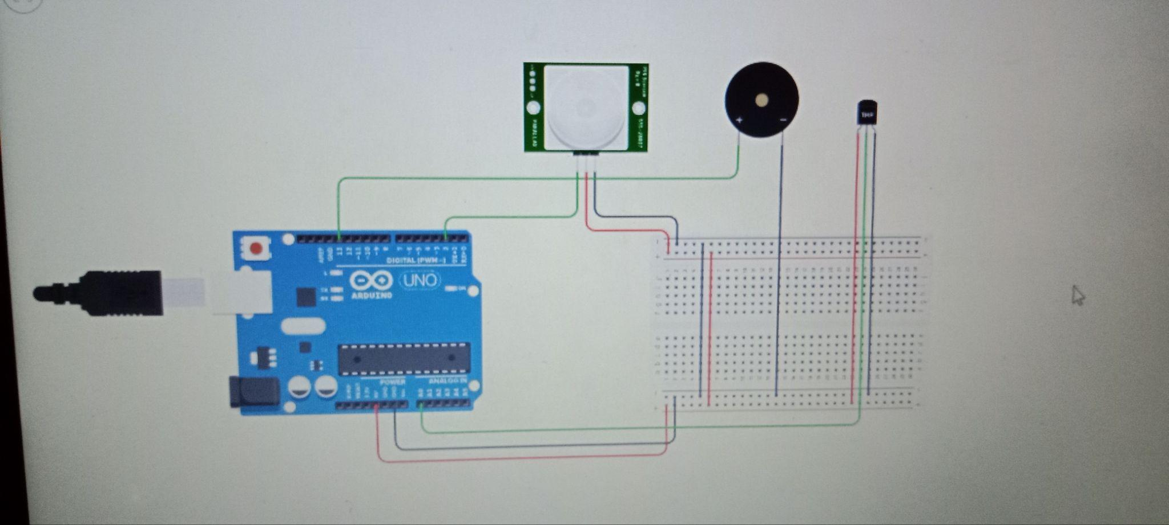

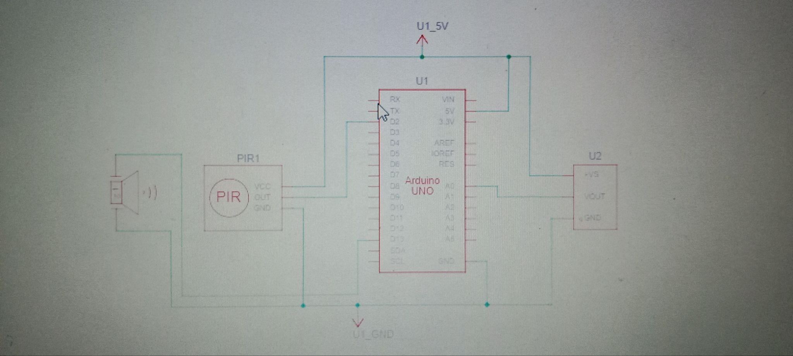

Code:

int baselineTemp = 0;

int celsius = 0;

int motion=digitalRead(2);

void setup()

{

pinMode(A0, INPUT);

pinMode(2, INPUT);

Serial.begin(9600);

pinMode(13, OUTPUT);

}

void loop()

{

baselineTemp =60; celsius = map(((analogRead(13) - 20) * 3.04), 0, 1023, -40, 125);

if (celsius < baselineTemp)

{

digitalWrite(13, LOW);

}

if (celsius > baselineTemp)

{

digitalWrite(13, HIGH);

for(int freq=0;freq<=30000;freq++)

tone(13, freq);

delay(1000);

noTone(12);

delay(500);

}

if (motion==1)

{

digitalWrite(13, HIGH);

for(int freq=0;freq<=30000;freq++)

tone(13, freq);

delay(1000);

noTone(12);

delay(500);

}

}